**Services Offered**

* Educational Counselling
* Course Selection
* University Selection
* Offers & Admissions in Universities / Colleges
* Pre-Departure and Post-Arrival Services
* English language classes
* Registration for Entrance and English tests
* Scholarship Assistance
* Visa Assistance

<https://www.theeducationgroup.net/blank-3>

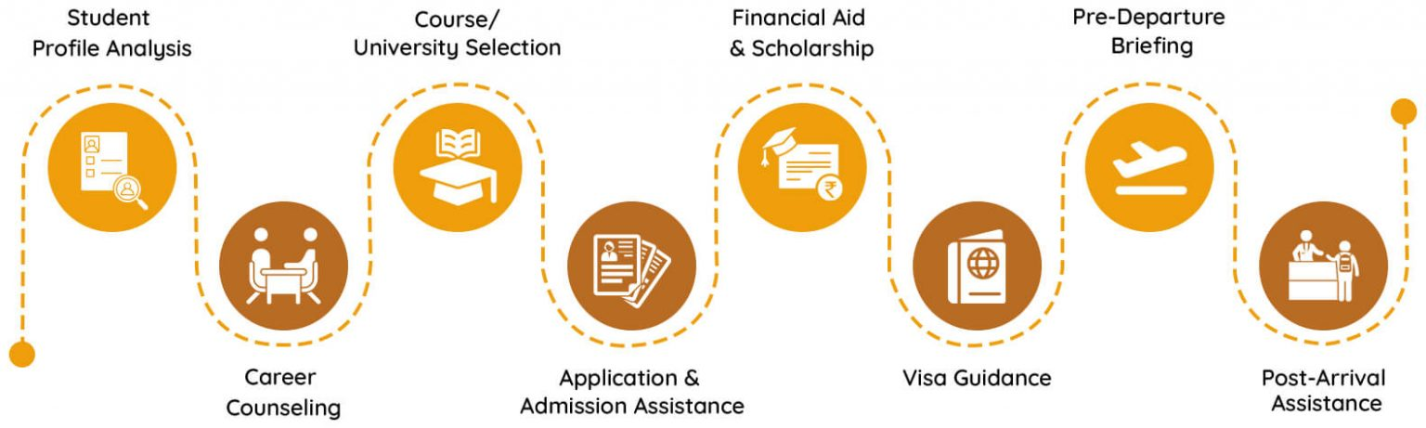

<https://1sass.com/services/>